1st EXP obj 1 code and output
clc;
clear;
close all;
% Parameters
fs = 1000; % Sampling frequency
t = 0:1/fs:1; % Time vector (1 second)
TBW = 600; % Total Bandwidth (kHz)
Users = 3; % Number of users
CBW = TBW / Users; % Bandwidth per user
% Carrier frequencies
fc = [100 300 500];
% Message signal
m = sin(2*pi*10*t);
% FDMA signals
s1 = m .* cos(2*pi*fc(1)*t);
s2 = m .* cos(2*pi*fc(2)*t);
s3 = m .* cos(2*pi*fc(3)*t);
% Plot transmitted signals
subplot(2,1,1);
plot(t, s1, 'r', t, s2, 'g', t, s3, 'b');
grid on;
title('FDMA Channel Allocation');
xlabel('Time (s)');
ylabel('Amplitude');
legend('User 1','User 2','User 3');

% Plot channel bandwidth allocation
subplot(2,1,2);
bar(1:Users, CBW*ones(1,Users));
grid on;
title('Channel Bandwidth per User');
xlabel('Users');
ylabel('Channel Bandwidth (kHz)');
xticklabels({'User 1','User 2','User 3'});

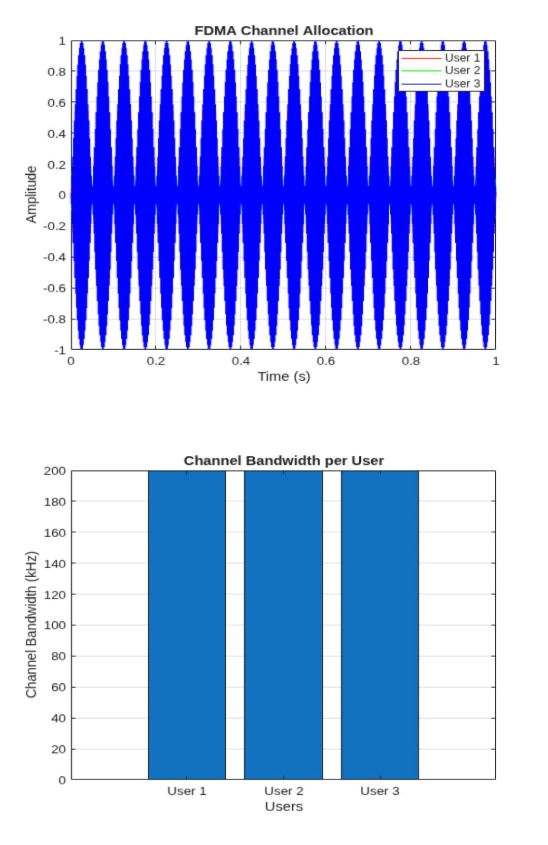
EXP 1 OBJ 2 CODE AND OUTPUT
clc; clear; close all;
BW = 200; % Channel Bandwidth (kHz)
Users = 3;
M = 2; % BPSK Modulation
DataRate = BW*log2(M); % Data Rate (kbps)
Rate = DataRate*ones(1,Users);
disp(' User Data Rate (kbps)')
disp([(1:Users)' Rate'])
figure
bar(1:Users,Rate)
xlabel('Users')
ylabel('Data Rate (kbps)')
title('FDMA Data Rate for Each User')
grid on
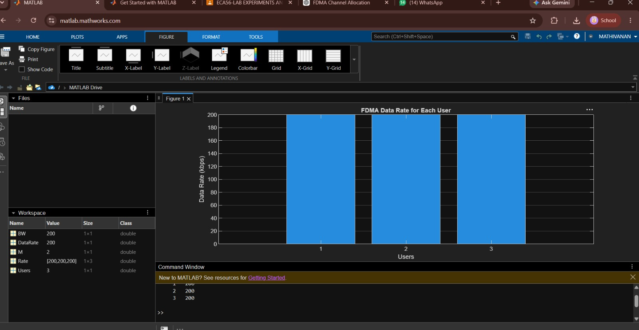

EXP 1 OBJ 3 CODE AND OUTPUT

clc; clear; close all;
FrameTime = 4.615; Slots = 8;
SlotDuration = FrameTime/Slots;

t = 0:SlotDuration:FrameTime;
figure
subplot(2,1,1)
stem(t,ones(size(t)),'filled')
title('TDMA Time Slot Structure')
xlabel('Time (ms)')
ylabel('Slot Level')
grid on
subplot(2,1,2)
plot(t,ones(size(t)),'-o','LineWidth',1.5)
title('Continuous View of Slot Allocation')
xlabel('Time (ms)')
ylabel('Slot Presence')
grid on

